Student Performance Prediction System

Project Id: AIML-8
Name : Vaibhavi Thapliyal(Team Leader)
Class Roll Number: 76
University Roll Number : 2028897
Section and Group: Q Group 2

Name : Naina Vashishtha
Class Roll Number: 53
University Roll Number : 2028774
Section and Group: Q Group 2

Name : Samiksha Gurung
Class Roll Number:66
University Roll Number : 2028836
Section and Group: Q Group 2

TABLE OF CONTENTS
- Problem Description 3
  - Dataset Description 3
  - Flow diagram 4
- Modules for Project Implementation…………………..…………………………5
  - Modules Used 5
  - Platform Used 6
- Machine Learning model/ Searching Technique used 7
- Evaluation metrics used 8
- Results and Visualizations 10
- Conclusion and Future Scope 12
- References 13

- Problem Description
The Credit Risk Prediction System is a Python-based machine learning application developed to automate the analysis and prediction of loan default risk. It streamlines the process of collecting customer financial data, training predictive models, and generating risk insights while maintaining accuracy and efficiency.
Using core concepts of Machine Learning such as data preprocessing, feature scaling, handling class imbalance using SMOTE, classification algorithms, model evaluation, and data visualization techniques, this project reduces manual effort in assessing creditworthiness.
The system analyzes customer attributes like income, credit score, employment type, loan details, and financial history to identify potential defaulters. This helps financial institutions make informed, data-driven decisions, minimize financial risk, and improve loan approval processes.

1.1 Dataset Description

The dataset used in this project contains financial and demographic information of customers, which is used to predict whether a customer is likely to default on a loan.
It consists of 1800 records and 17 features, including both numerical and categorical variables. Each row represents an individual customer, and the target variable indicates whether the customer defaulted on a loan.
Features Description
- Age – Age of the customer
- Employment_Type – Type of employment (Salaried / Self-Employed)
- Years_of_Employment – Total years of work experience
- Annual_Income – Yearly income of the customer
- Savings_Balance – Amount of savings
- Bank_Balance – Current bank balance
- Credit_Score – Creditworthiness score of the customer
- Debt_to_Income_Ratio – Ratio of debt to income
- Existing_Loans_Count – Number of existing loans
- Loan_Amount_Requested – Loan amount requested by the customer
- Loan_Term – Duration of the loan
- Missed_Payments – Number of missed payments
- Num_of_Credit_Inquiries – Number of credit checks made
- Credit_Card_Utilization – Percentage of credit card usage
- Residence_Type – Type of residence (Owned / Rented)
- Dependents_Count – Number of dependents
- Default – Target variable (0 = No Default, 1 = Default)
Dataset Characteristics
- The dataset contains a mix of numerical and categorical features
- No missing values were initially present in the dataset
- The target variable is binary (classification problem)
- The dataset initially showed class imbalance, which was handled using SMOTE

1.2 Flow Diagram

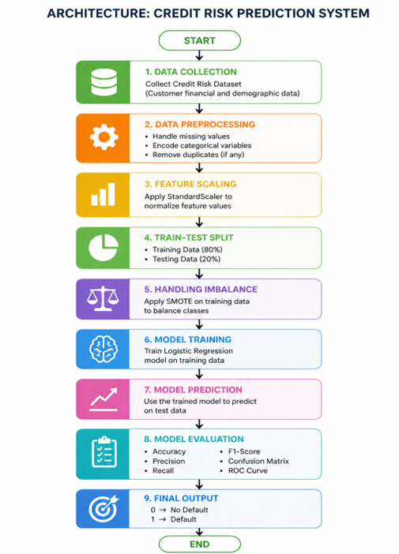

Fig.1 Sample flow diagram.

2. Modules for Project Implementation

2.1 Modules Used
The project uses various inbuilt and external Python modules for data handling, model building, evaluation, and deployment.

1. Pandas
Pandas is used for data manipulation and analysis.
Functions used:
- pd.read_csv() – to load dataset from CSV file
- df.head() – to view first few rows
- df.info() – to understand data types and structure
- df.describe() – to get statistical summary
- df.drop() – to remove unnecessary col

2. NumPy
NumPy is used for numerical operations and array handling.
Functions used:
- np.array() – to convert input data into array format
- np.reshape() – to reshape data when required

3. Matplotlib
Matplotlib is used for data visualization.
Functions used:
- plt.figure() – to create a new plot
- plt.show() – to display the plot

4. Seaborn
Seaborn is used for advanced data visualization.
Functions used:
- sns.heatmap() – to visualize correlation matrix
- sns.histplot() – to show data distribution
- sns.boxplot() – to detect outliers

5. Scikit-learn
Scikit-learn is used for machine learning model building and evaluation.
Functions used:
- train_test_split() – to split data into training and testing sets
- StandardScaler() – for feature scaling
- LogisticRegression() – for classification
- RandomForestClassifier() – for improved accuracy
- accuracy_score() – to calculate accuracy
- precision_score() – to evaluate model precision
- f1_score() – to measure model performance
- confusion_matrix() – to evaluate prediction results
- classification_report() – to summarize performance

6. Imbalanced-learn (SMOTE)
SMOTE is used to handle imbalanced dataset.
Functions used:
- SMOTE() – to generate synthetic samples for minority class

7. Pickle
Pickle is used to save and load trained model and scaler.
Functions used:
- pickle.dump() – to save model and scaler
- pickle.load() – to load model and scaler

8. Streamlit
Streamlit is used to create an interactive web application.
Functions used:
- st.title() – to display title
- st.number_input() – to take numeric input
- st.selectbox() – for dropdown input
- st.button() – to trigger prediction
- st.success() – to display positive result
- st.error() – to display warning result

2.2 Platform Used:

The project was developed and executed using the following platforms:

1. Jupyter Notebook
Jupyter Notebook was used for data analysis, preprocessing, and model building.
Reason for use:
- Provides an interactive environment for writing and testing code
- Helps in step-by-step execution and debugging
- Supports visualization of graphs and outputs easily

2. Anaconda Prompt
Anaconda Prompt was used to run the Streamlit application.
Reason for use:
- Provides a controlled Python environment
- Allows execution of commands like streamlit run app.py
- Ensures proper package management and dependency handling

3. Streamlit
Streamlit was used to deploy the machine learning model as a web application.
Reason for use:
- Enables quick development of interactive web interfaces
- Allows real-time user input and prediction
- Easy to integrate with machine learning models

4. Visual Studio Code (optional)
Visual Studio Code can be used for writing and editing Python scripts.
Reason for use:
- Provides better code organization
- Supports extensions and debugging tools
- Improves development efficiency

5. GitHub
GitHub was used for storing and sharing project files.
Reason for use:
- Enables version control
- Allows collaboration among team members
- Makes the project accessible online

3. Machine Learning Model/ Searching Technique Used

The project uses machine learning models to predict whether a customer is likely to default on a loan based on financial and credit-related features.

1. Logistic Regression
Logistic Regression is a supervised machine learning algorithm used for binary classification problems.
Description:
- It predicts the probability of an outcome (0 or 1) using a sigmoid function
- Converts input features into a probability score between 0 and 1
Why it is used:
- Simple and easy to interpret
- Works well for baseline classification
- Helps understand relationship between features and target variable
Application in the project:
- Used as the initial model to classify customers as default (1) or non-default (0)

2. Random Forest Classifier
Random Forest is an ensemble learning algorithm that uses multiple decision trees.
Description:
- Combines predictions of multiple decision trees
- Uses majority voting for classification
- Reduces overfitting compared to a single decision tree
Why it is used:
- Provides higher accuracy
- Handles complex relationships in data
- Works well with both numerical and categorical features
Application in the project:
- Used as the final model for prediction
- Improved performance compared to Logistic Regression

3. SMOTE (Synthetic Minority Oversampling Technique)
SMOTE is a data balancing technique used to handle imbalanced datasets.
Description:
- Generates synthetic samples for the minority class
- Balances the dataset without duplicating existing data
Why it is used:
- Prevents model bias toward majority class
- Improves prediction for minority class (default cases)
Application in the project:
- Applied before training the model to balance the dataset

4. Feature Scaling (Standardization)
Feature scaling is used to normalize input data.
Description:
- Transforms data so that it has mean = 0 and standard deviation = 1
Why it is used:
- Ensures all features contribute equally
- Improves model performance and convergence
Application in the project:
- Applied using StandardScaler before training

4. Evaluation metrics used

Evaluation metrics are used to measure the performance of the machine learning model and assess how accurately it predicts loan default.

1. Accuracy Score
Description:
Accuracy measures the overall correctness of the model by calculating the proportion of correct predictions out of total predictions.
Formula:
$$Accuracy=\frac{TP+TN}{TP+TN+FP+FN}$$
Where:
- TP = True Positives
- TN = True Negatives
- FP = False Positives
- FN = False Negatives
Use in project:
Used to evaluate the overall performance of the model.

2. Precision
Description:
Precision measures how many of the predicted positive cases are actually correct.
Formula:
$$Precision=\frac{TP}{TP+FP}$$
Use in project:
Important when false positives need to be minimized (predicting default incorrectly).

3. Recall (Sensitivity)
Description:
Recall measures how many actual positive cases are correctly identified.
Formula:
$$Recall=\frac{TP}{TP+FN}$$
Use in project:
Important for identifying actual defaulters correctly.

4. F1-Score
Description:
F1-score is the harmonic mean of precision and recall, providing a balance between both.
Formula:
$$F1=\frac{2×Precision×Recall}{Precision+Recall}$$
Use in project:
Used when both precision and recall are equally important.

5. Confusion Matrix
Description:
A confusion matrix is a table used to evaluate the performance of a classification model.
 | Predicted Positive | Predicted Negative
Actual Positive | TP | FN
Actual Negative | FP | TN
Use in project:
Helps visualize model performance and identify types of errors.

6. Classification Report
Description:
Provides a detailed summary of precision, recall, F1-score, and support for each class.
Use in project:
Used to analyze model performance for both classes (default and non-default).

5. Results and Visualizations

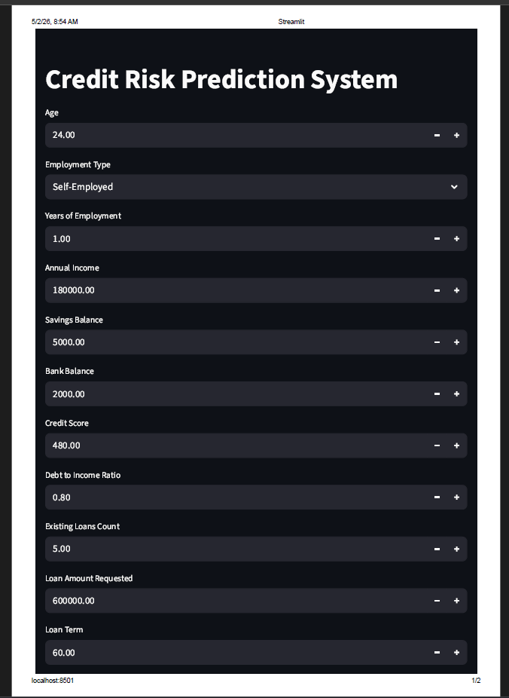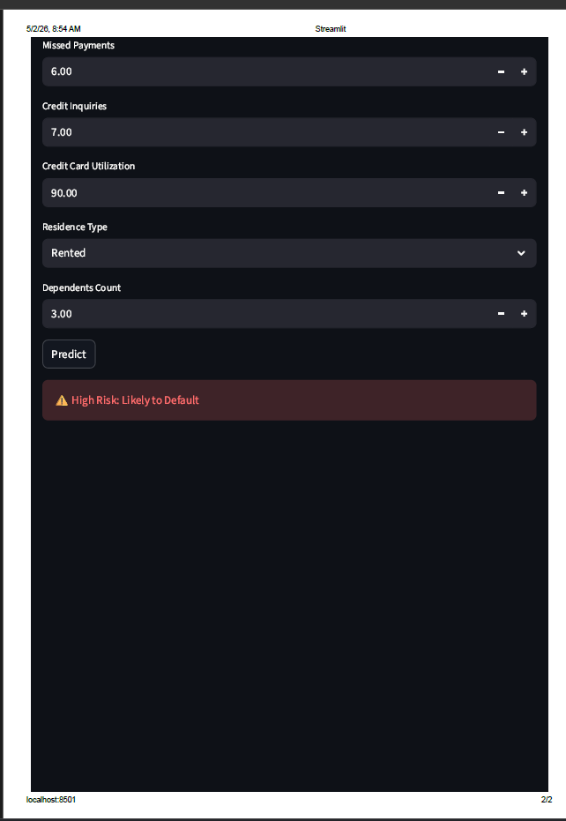

Fig 2: Likely to Default

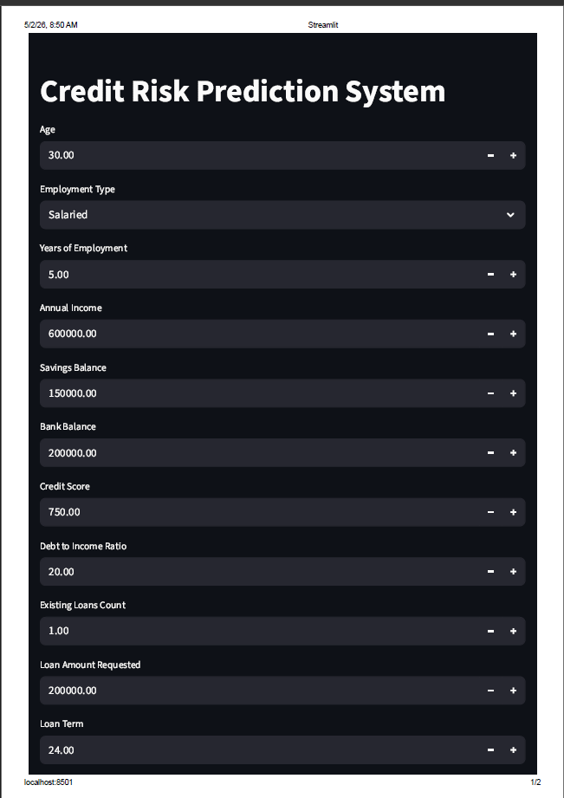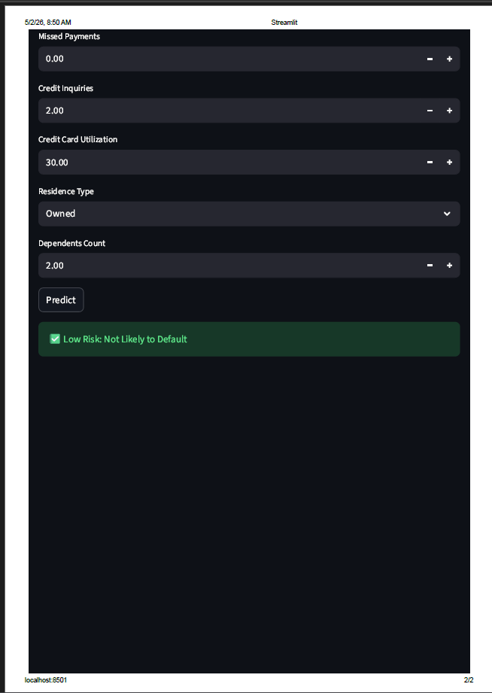

Fig 3:Not Likely To Default

6. Conclusion and Future Scope:

Conclusion
The Credit Risk Prediction System was successfully developed using machine learning techniques to predict whether a customer is likely to default on a loan.
The project involved data preprocessing, handling imbalanced data using SMOTE, feature scaling, and training models such as Logistic Regression and Random Forest. Among these, Random Forest provided better performance and was selected as the final model.
The model was evaluated using metrics such as accuracy, precision, recall, and F1-score, which confirmed that the system performs effectively in identifying potential defaulters.
Additionally, the model was deployed using Streamlit, creating an interactive user interface where users can input customer details and receive real-time predictions.
Overall, the system helps in making informed financial decisions and reduces the risk associated with loan approvals.

Future Scope
The project can be further improved and expanded in the following ways:
- Use of Advanced Algorithms:
More advanced models like Gradient Boosting or XGBoost can be used to improve prediction accuracy.
- Hyperparameter Tuning:
Techniques like Grid Search can be applied to optimize model performance.
- Deployment on Cloud:
The application can be hosted online instead of running locally, making it accessible to a wider audience.
- Larger and Real-world Dataset:
Using real banking data can improve the reliability and robustness of the model.
- Feature Engineering:
Additional features can be created to enhance model performance.
- User Authentication System:
Add login functionality to make the system more secure.
- Integration with Banking Systems:
The model can be integrated into real financial systems for automated decision-making.

7. References:

Books:
- Yashavant Kanetkar, Let Us Python, BPB Publications

Online Resources:
- GeeksforGeeks – https://www.geeksforgeeks.org/
- TutorialsPoint – https://www.tutorialspoint.com/python/index.htm
- Stack Overflow – https://stackoverflow.com/

Documentation & Libraries:
- Scikit-learn Documentation – https://scikit-learn.org/
- Pandas Documentation – https://pandas.pydata.org/
- NumPy Documentation – https://numpy.org/
- Matplotlib Documentation – https://matplotlib.org/
- Seaborn Documentation – https://seaborn.pydata.org/
- Imbalanced-learn (SMOTE) Documentation – https://imbalanced-learn.org/

